**Лабораторная работа 13**

**Конструирование программного обеспечения**

**Подготовка к разработке лексического распознавателя**

**Вариант2**

open(□)+ ((write+read+seek);)+□ + close

**Задание 1**

1. open □, write; □ close
2. open □□, write; read; seek; read; seek; □, □□ close
3. open □, write; write; seek; read; read; seek; write; seek; seek; □ close
4. open □□, write; read; seek; □ close
5. open □□□, write; write; write; □, □□, □□□, close
6. open □, write; seek; read; □ close
7. open □□, write; read; read; read; write; □, □□, □□□, close

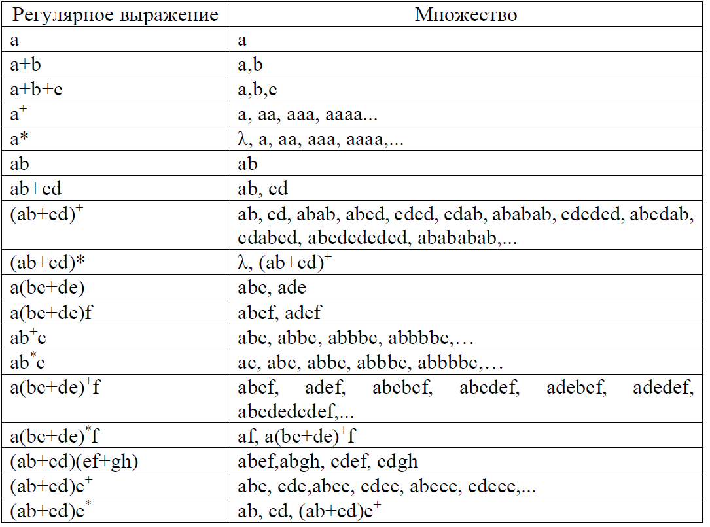

**Задание 2**

open □□, write; seek; read; □ close

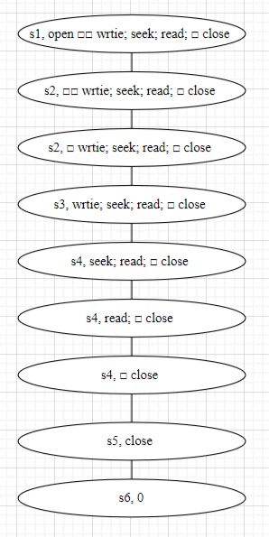

**Задание 3**

open(□)+ ((write+read+seek);)+□ + close

|  |  |  |  |  |  |  |
| --- | --- | --- | --- | --- | --- | --- |
|  | a | b | c | d | e | f |
| s1 | s2 |  |  |  |  |  |
| s2 |  | s2,  s3 |  |  |  |  |
| s3 |  |  | s4 | s4 | s4 |  |
| s4 |  |  | s4, s5 | s4, s5 | s4, s5 |  |
| s5 |  | s5, s6 |  |  |  |  |
| s6 |  |  |  |  |  |  |

